**Types of JavaScript Functions**

Any function created using different ways of creating JavaScript functions, will be of one of the below mentioned type.

1. A function without parameters and without returning value

2. A function without parameters and with returning value

3. A function with parameters and without returning value

4. A function with parameters and with return value

5. [Anonymous function.docx](Anonymous%20function.docx)

6. [Recursive function.docx](Recursive%20function.docx)

7. Pure function

8. [Array function](Array%20function.docx)

Remember: [Return keyword.docx](Return%20keyword.docx)

**Creating different types of functions using function declaration:**

**1) A function without parameters and without returning value**

**Syntax:**

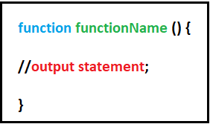

**Example:**

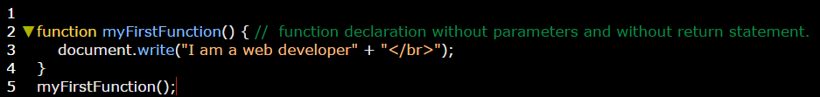

**2) A function without parameters and with returning value**

**Syntax:**

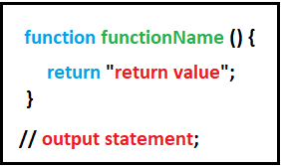

**Example 1:**

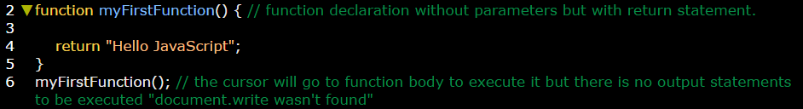

**Example 2:** you can display return value "Hello JavaScript" by using variables where vaiable will store function statements inside it. And by calling the variable we can display it.

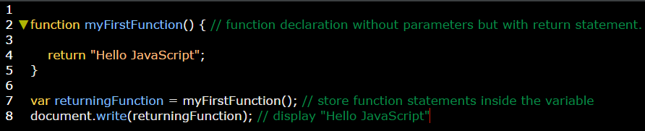

**How the previous example will be executed?**

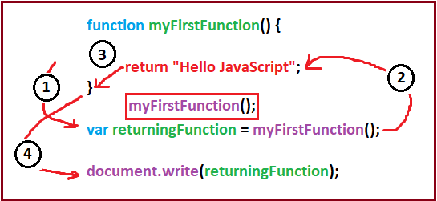

And again you can make sure by debugging this code in your browser.

**Example 3:** you can easily display return value directly by using function name (If you don’t need to use variables).

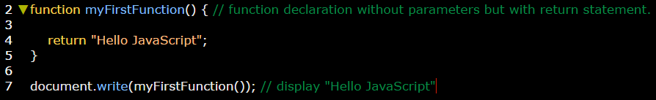

**3) A function with parameters and without returning value**

Parameter is a variable used to store value. So if you want to make a function can display more than one value, then this type is a good choose.

**Example 1:**

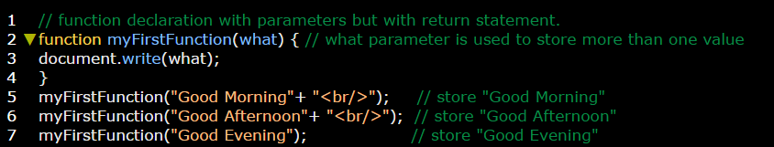

**How this example runs?**

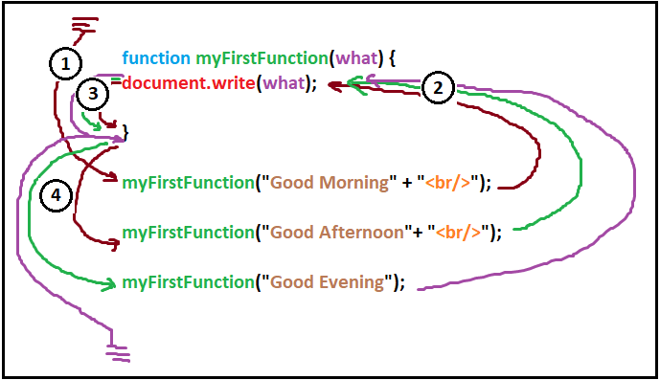

**Again you can tracking this code in your browser and show the sored value in the parameter step by step. Like the yellow rectangle.**

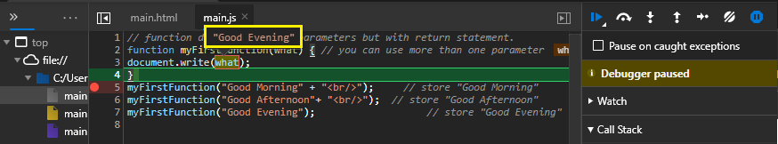

**Example 2:** function with more than one parameter.

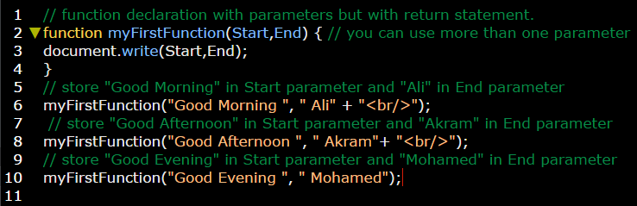

This example is run also as the previous one.

**4) A function with parameters and with return value**

Parameter is a variable used to store value. So if you want to make a function can display more than one value, then this type is a good choose.

**Example 1:**

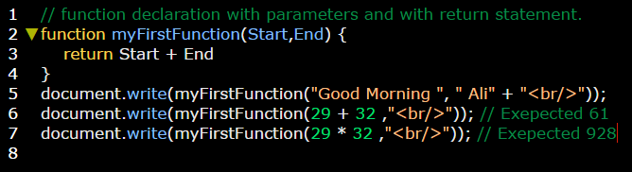

This type is similar to the previous one on how it works.